OCCUPATIONAL EDUCATION DIVISION
PROGRAM DIRECTORS

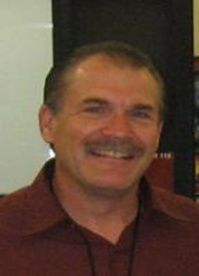 | James Cerven  Program Director:  Administrative Justice Studies - 623.935.8924 |  | Steven Griffiths  Program Director:  Culinary Institute - 623.935.8862
 | Amy Hill  Program Director:  Speech Language Pathology - 623.935.8853 |  | Rachel Holmes  Program Director:  Teacher Education  Institute - 623.935.8407
 | Mike Pineda  Program Director:  Business Institute - 480.784.0597 | Image coming soon | Energy Institute:  For more information please contact the Division Chair:  Dr. Rachel Holmes

